**Unit 1 User manuals and instructions**



**a definition of technical communication:** Technical communication is a process of managing technical information in ways that allow people to take action. -- Richard Johnson-Sheehan

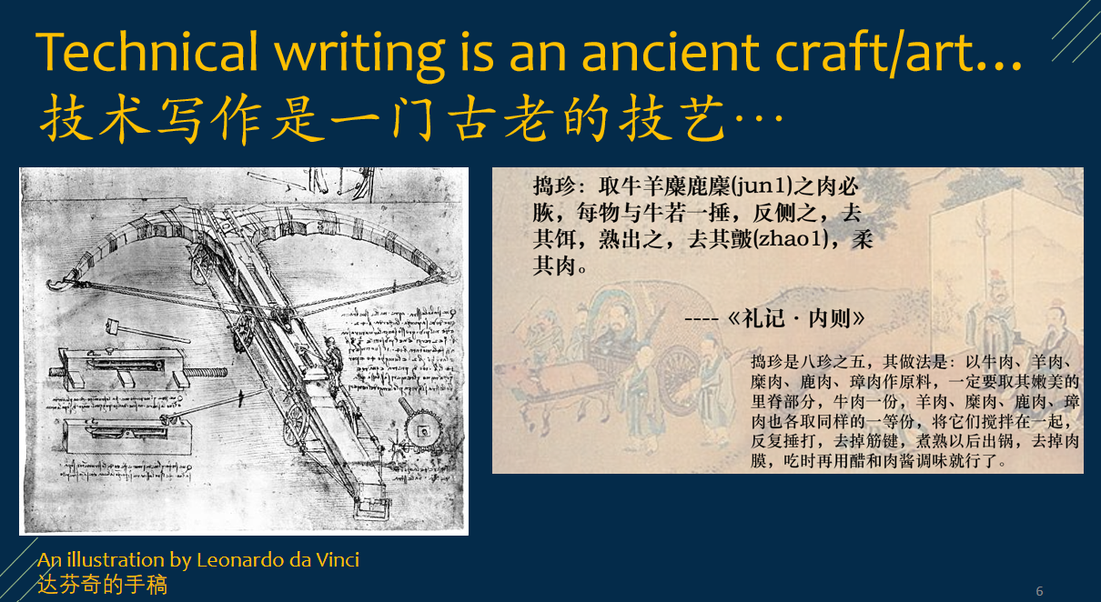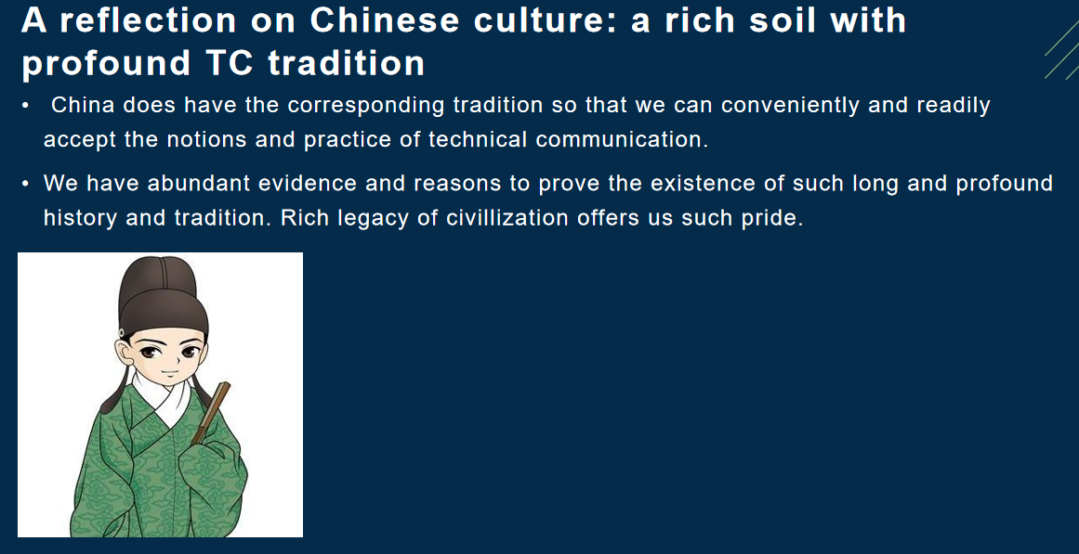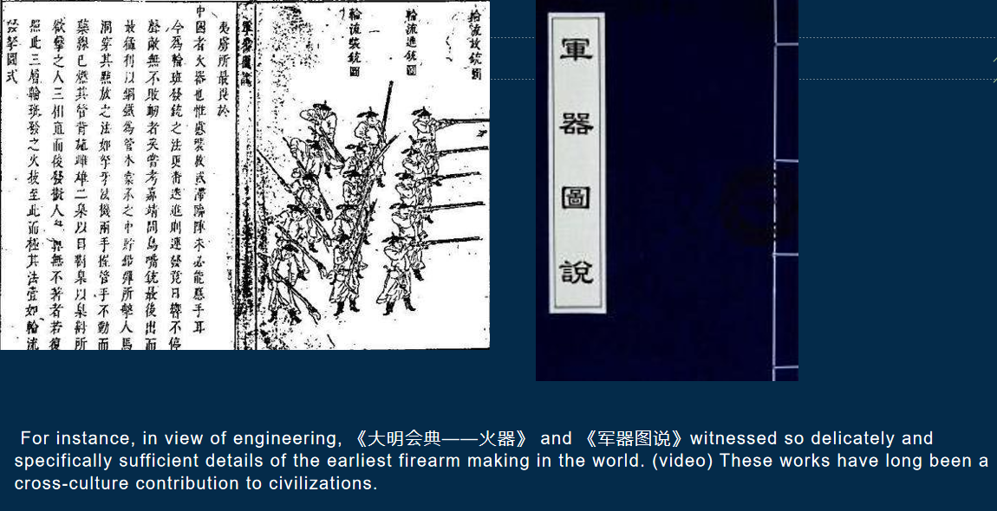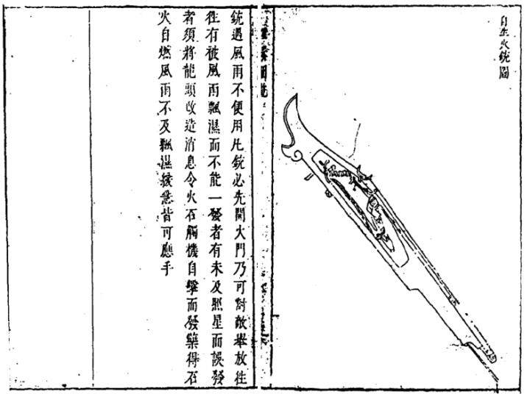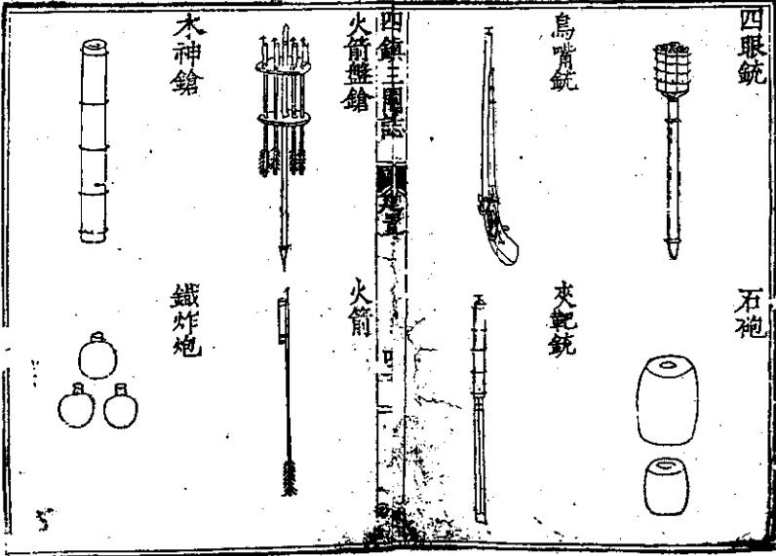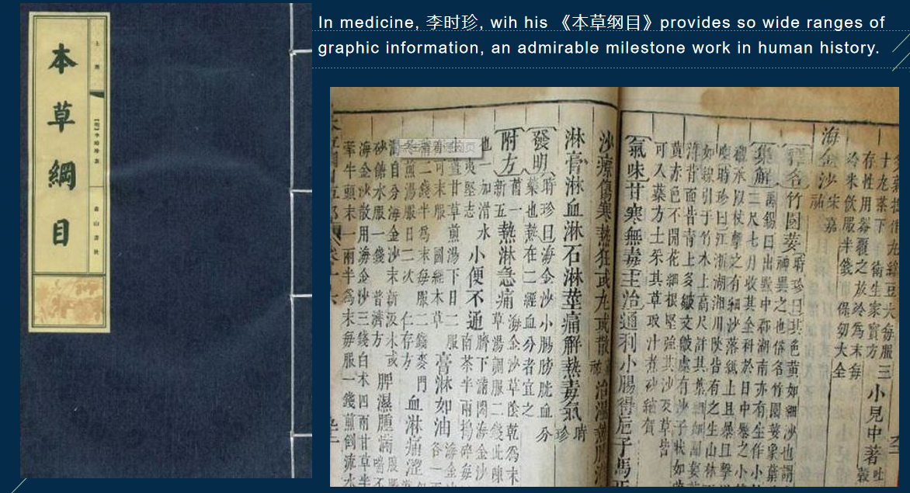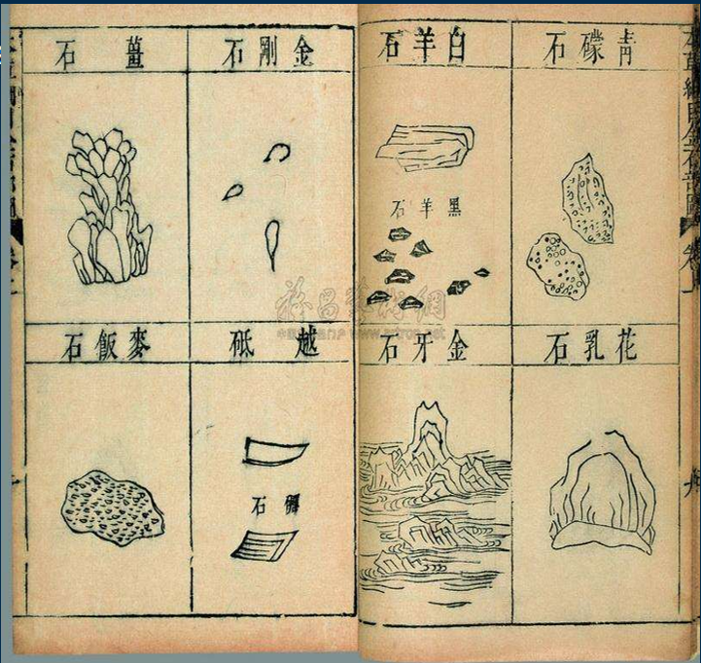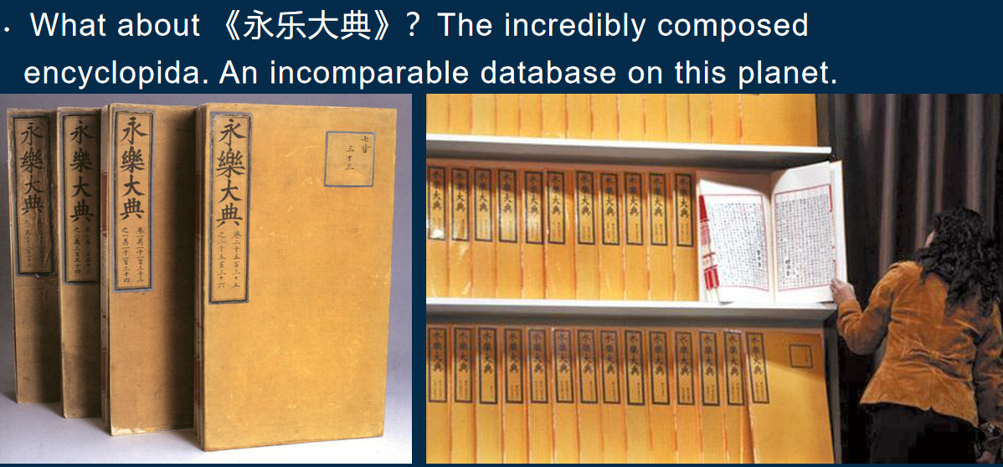

**Basic qualities of technical communication**



***Technical communication is:

**--interactive and adaptable**

**--reader centered**

**--reliant on teamwork**

**--visual**

**--bound ethically, legally and politically**

**--international and transcultural**

***For the READER-CENTERED(user-centered/reader-focused) quality we need to know:

**Users don't read. 不咬文嚼字**

**Users don't scroll. 无耐心**

**Users are easily lost. 易误导**

**Users are easily frustrated. 易疲劳**

**Users are strangely persistent. 耽于习惯**

**Users are different. 人各不同**

策略提示： 什么是最好的说明（文案）？

The best instruction is no instruction (invisible & intuitive). 最好的说明，应符合实践规律（贯穿于无形与习惯）

要做的设计可称为：Intuitive design（符合用户直觉（习惯、需要、实际）的设计）

----------------------------------------------

**Writing definitions: three types of definitions**

 定义术语的概念与作用

--A definition clarifies a description of a new development or a new technology in a technical field.

e.g. A zoologist who has discovered a new animal species names and defines it.

--Definitions help specialists communicate with less knowledgeable readers.

e.g. A manual explaining how to tune up a car includes definitions of parts and tools.

定义术语的写作要求

Please be aware that ...

--For long documents, create a glossary (a list of definitions).列表

--Use simplified English and easily recognizable terms in definitions. 简明

--Pay close attention to key terms. 关键词

--Use graphics to help readers to understand a term of concept. 图示

定义术语列表如图

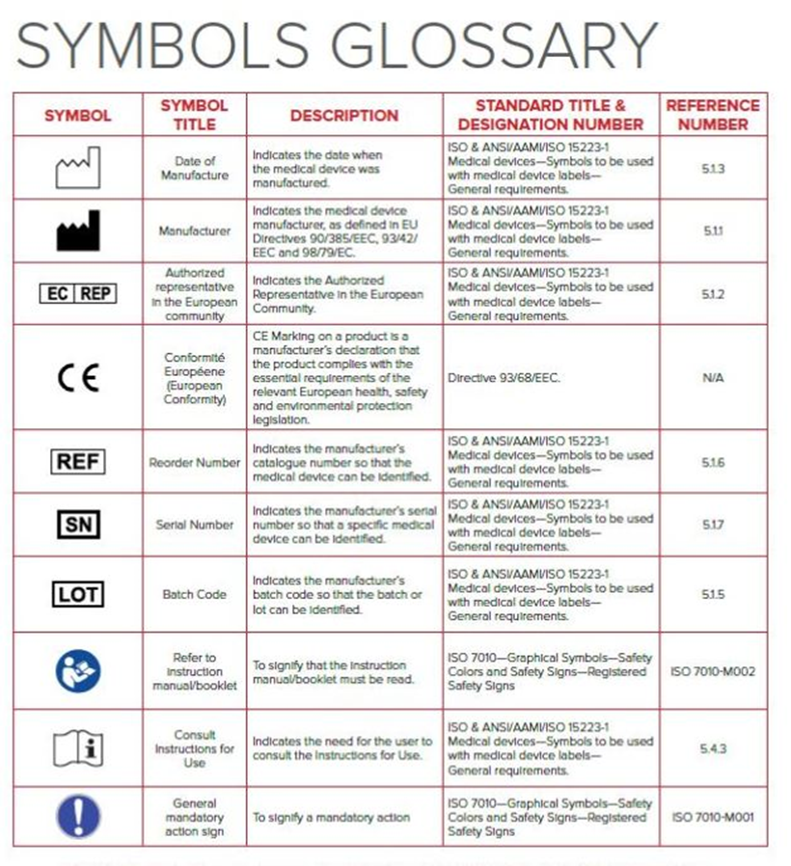

**Simplified English （SE）简明英语**

Main characteristics :主要特点

--Simplified grammar and style rules 语法与文体

--A limited set of approved vocabulary with restricted meanings 用语规范、意义明确

--A thesaurus of frequently used terms and suggested alternatives 同义语规范

--Guidelines for adding new technical words to the approved vocabulary 产生新技术用语应遵循规律与规范

注：工程师做工作记录、文档记录时要遵循各个行业的STE要求，保证技术资料一致性、可用性。如

英语的技术传播规范之一：ASD Simplified Technical English （a writing standard for aerospace maintenance documentation.）

相关网址：

http://www.asd-ste100.org/

http://www.boeing.com/company/key-orgs/licensing/simplified-english-checker.page

（图示如下）

For example, SE requires writers to: 写作者的操作要点

--Use the active voice 主动态

--Use articles wherever possible 冠词

--Use simple verb tenses 动词时态的一般式

--Use language consistently 语言的一致性

--Avoid lengthy compound words 用词避免冗长复杂

--Use relatively short sentences 用短句。

对比示例：

Original Version

Before filling the gas tank, it is necessary to turn off the propane line to the refrigerator. Failure to do so significantly increases the risk of explosion.

Simplified English Version

Before you pump gasoline into the gas tank, turn off the propane line to the refrigerator. If you do not turn off the propane line, it could explode.

注意：简明之要义在表意明确。如例，改进后采用从句句式，表达逻辑与步骤更为明晰；运用第二人称表达，文体浅近、亲和，适合用户阅读。

而又可根据情况采用祈使句式，如以下练习

Rewrite the following steps so that each begins with a verb in active voice and imperative mood.

--If you want to prevent colors from running, you need to separate dark clothes from light clothes.

--It is required that readers should read the passage and locate all nouns, which need to be underlined with a single line.

--The user should press the AUTO DEFROST button if he wants to begin the defrosting process.

Revision Key:

1.Separate dark clothes from light clothes to prevent colors from running.

2.Read the passage and locate all nouns; and then underline the nouns with a single line.

3. Press the AUTO DEFROST button to begin the defrosting process.)

**三类定义术语 THREE types of definitions**

**第一类 Parenthetical definitions 附注型**

( Not meant to be comprehensive.

A quick and convenient way of introducing terms.

)

The computers were infected by a Trojan horse (a destructive program that appears to be benign).

Before the metal is plated, it is immersed in the pickle: an acid bath that removes scales and oxides from the surface.

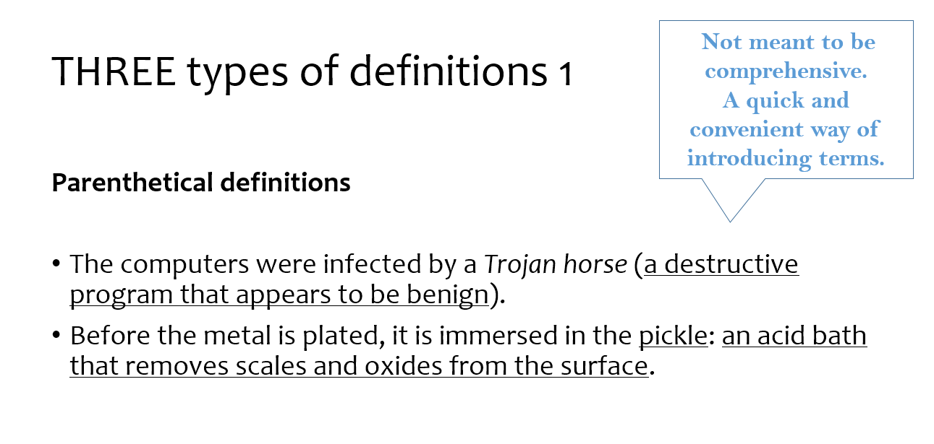

**第二类 Sentence definitions 整句型**

(如图)

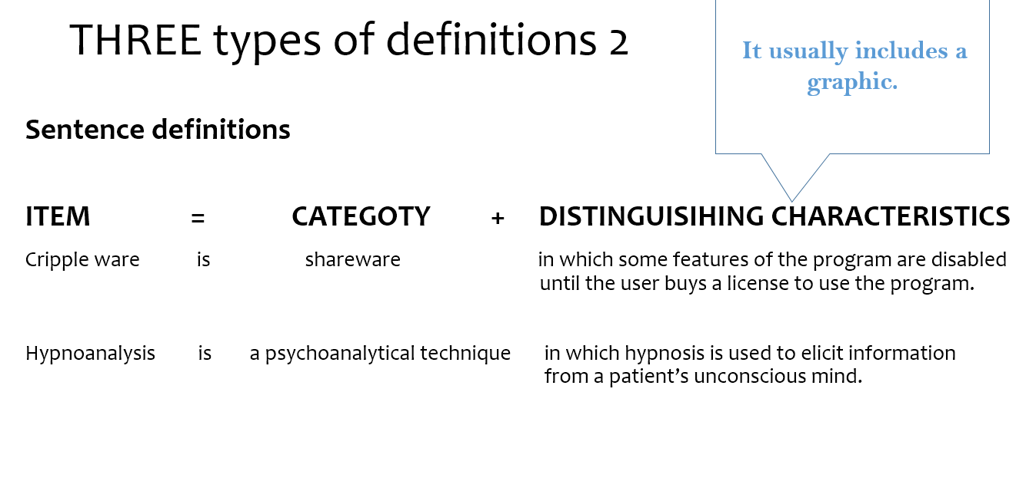

**第三类 Extended definitions 扩展型**

A more detailed explanation of an object, process, or idea.

Usually one or more paragraphs.

（如图）

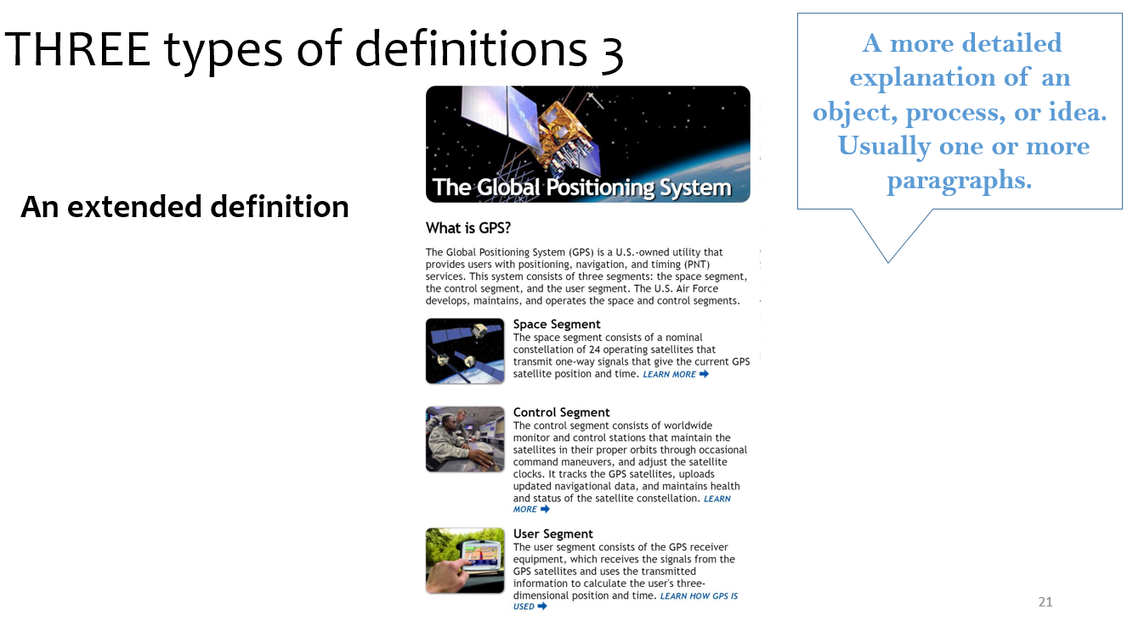

-----------------------------------------------

**Guidelines for writing descriptions**

**Technical communication often requires descriptions: verbal and visual representations of the physical or operational features of objects, mechanisms, and process.**

mechanism and object descriptions

For mechanism and object descriptions 描述有“机制”与“物件”类，各应采用适当原则

Choose an appropriate organizational principle.

功能型Functional: How the item works or is used.

空间型Spatial: based on the physical structure of the item

(e.g. from top to bottom, inside to outside, east to west, and so on)

Use graphics. 图示的使用：照片、制图、分解图

突出外观印象如照片-- **Photographs** to show external surfaces

展示部件规格如机械制图--**Drawings** to emphasize particular items on the surface

解析内部结构及关联机制如分解图**Cutaways** and **exploded diagrams** to show details beneath the surface.

(图示)

**Photograph如下**

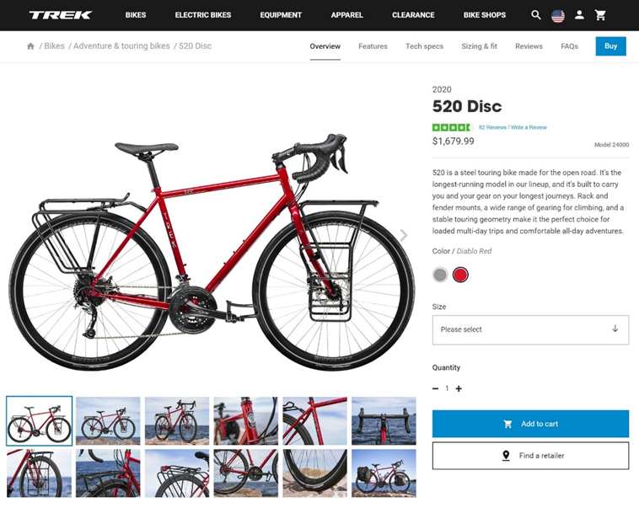

**Drawing**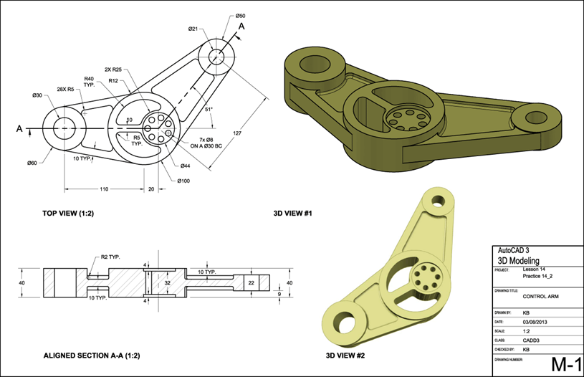

**Cutaway或exploded diagrams如下**

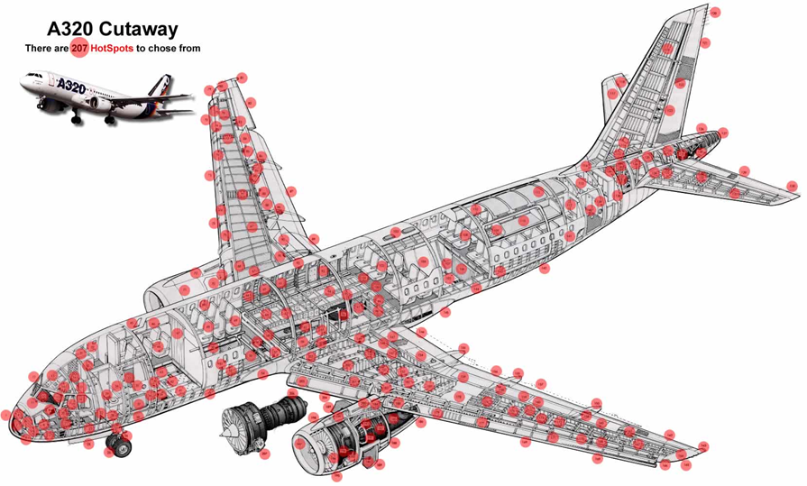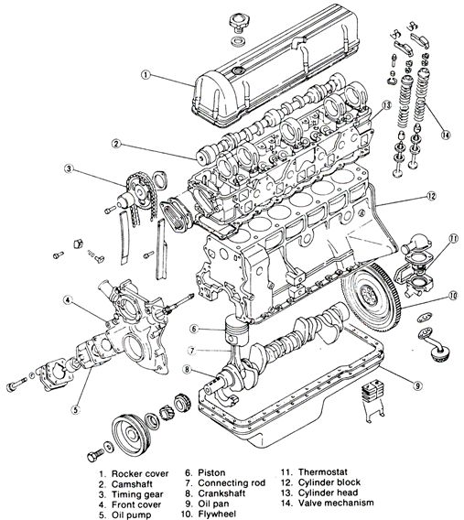

**\*\*\*For process descriptions**

（图示）

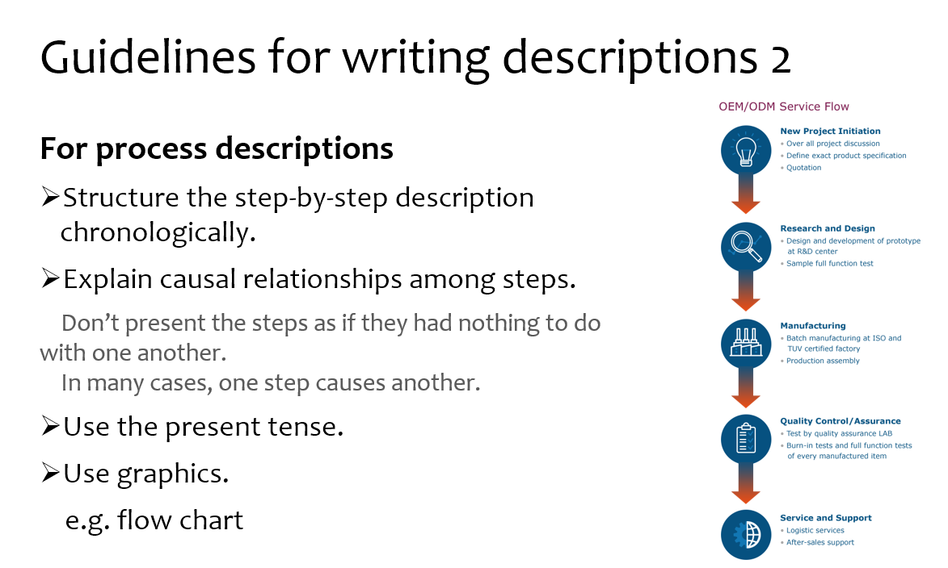

--------------------------------------------

**Instructions**

Definition:

Instructions are process descriptions written to help readers perform a specific task.

elements contained in instructions

a title

general introduction

step-by-step instructions

a conclusion



--------------------------------------------------

**Diagrammatic features**

图示1-3

**说明书常规页面**

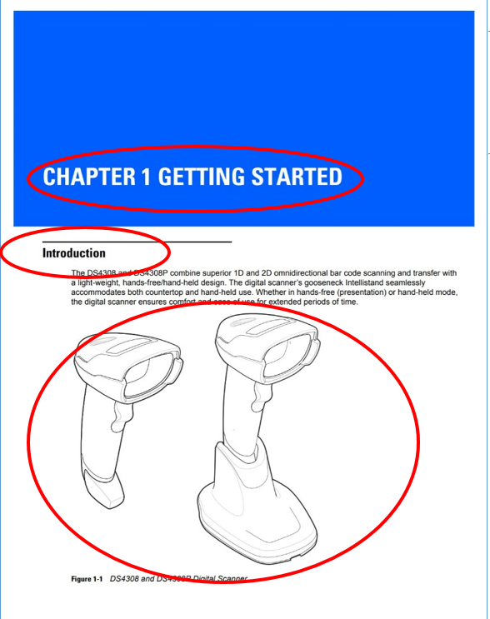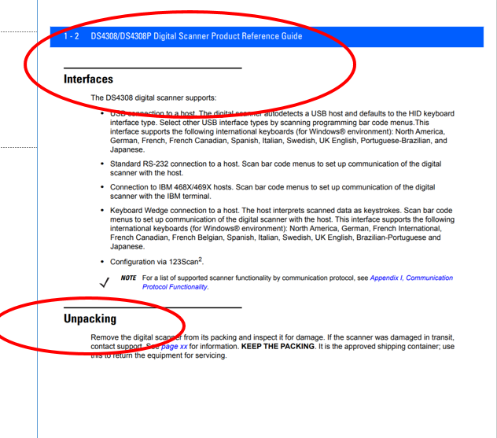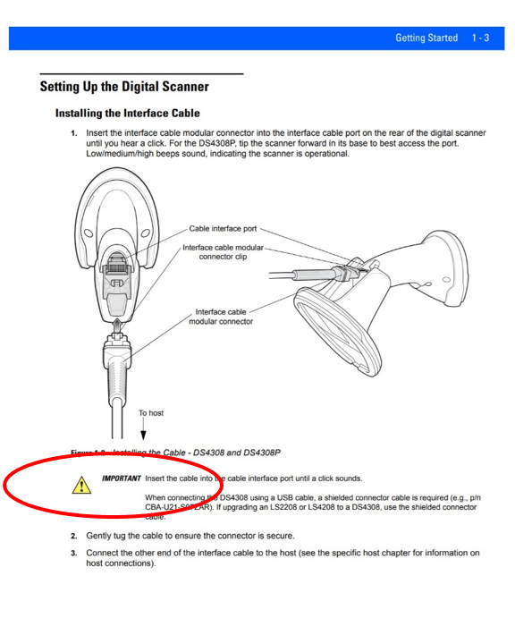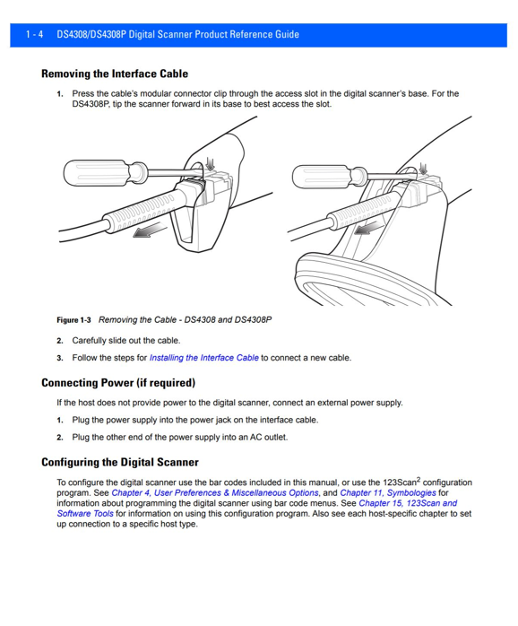

**多媒体说明文案：图示配合视频**

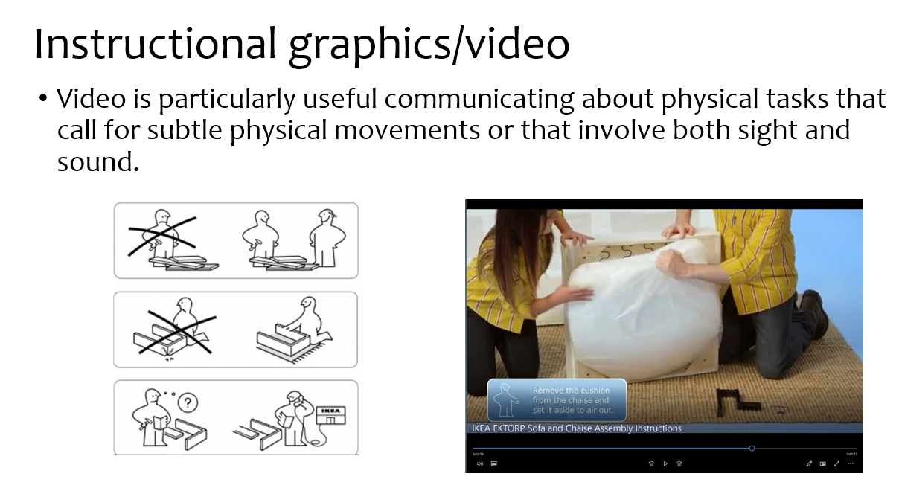

**Ways to improve the appearance**



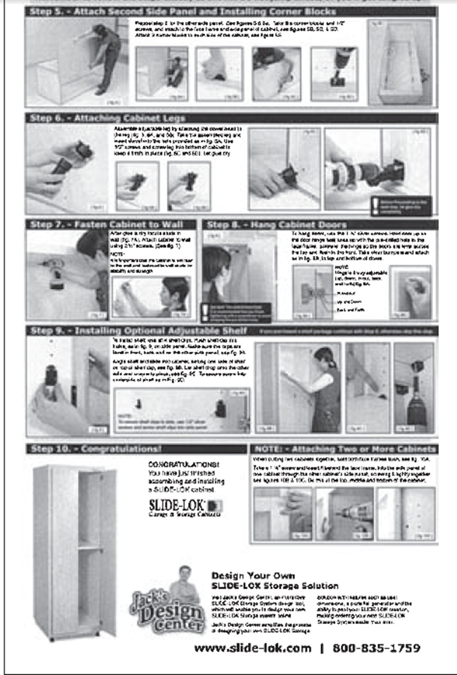

**Compared to the picture above the following plan for the assembly instructions is well designed, containing an appropriate amount of information (信息量适宜) presented in a simple two-column format (简明两栏格式). Notice the effective use of white space and the horizontal rules separating the steps（适当留白，横线划分步骤，效果鲜明）.**

**So, to achieve Clear and attractive designing we must**

**信息空间疏阔、层次分明--Create an open, airy design**

**图示--Use graphics**

**图文并茂--Relate graphics to text clearly**

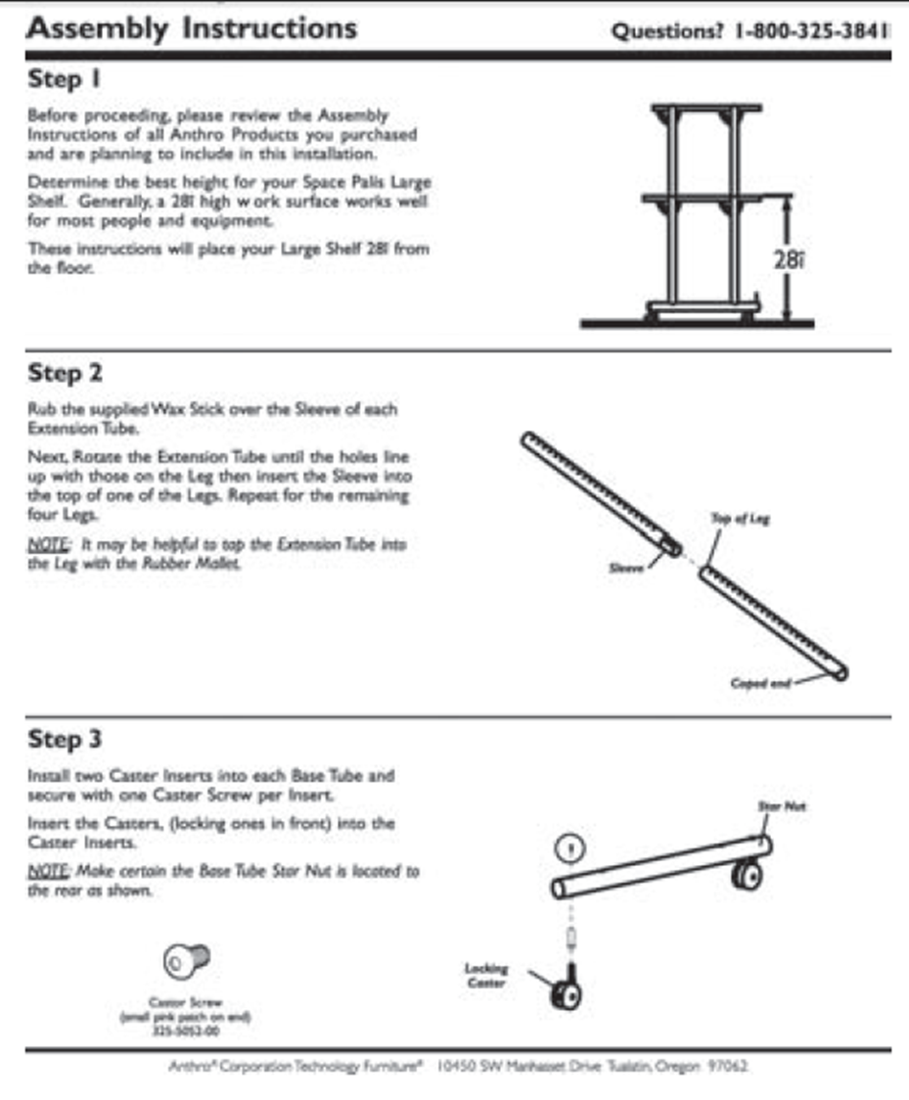

**Linguistic features**

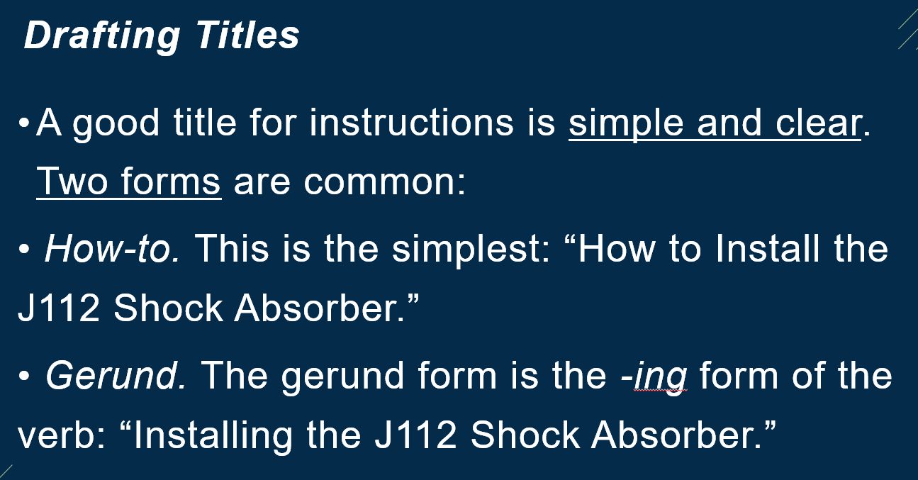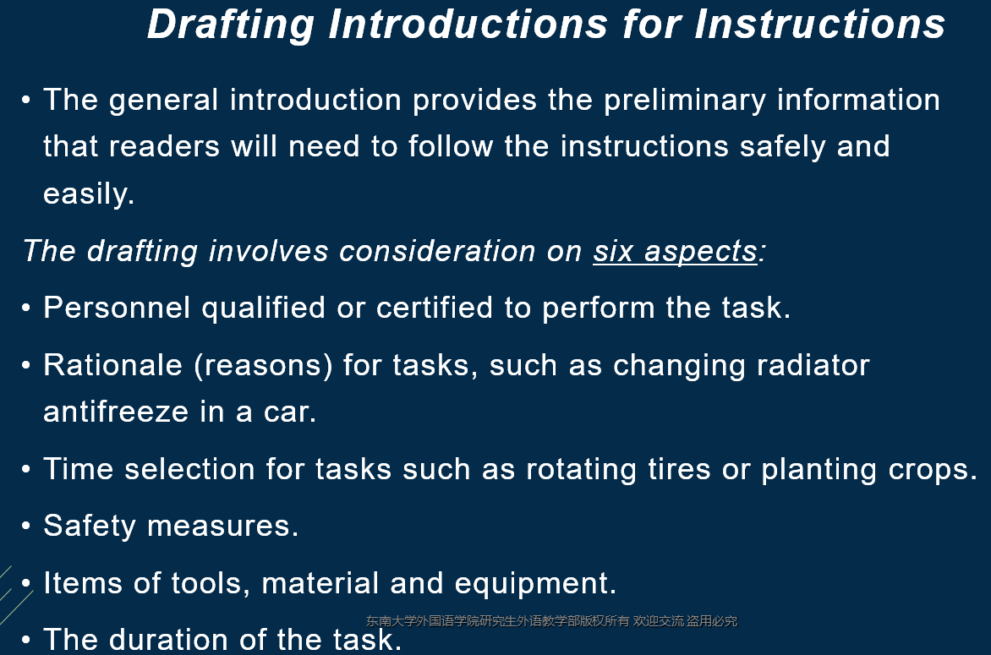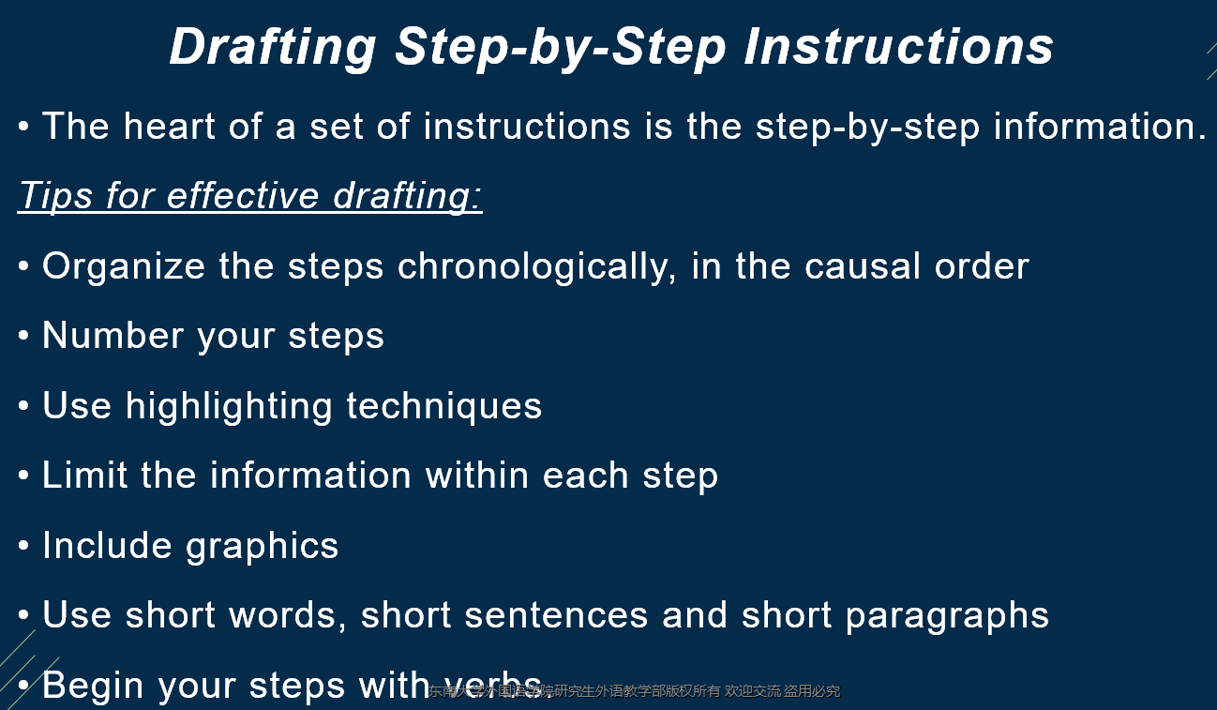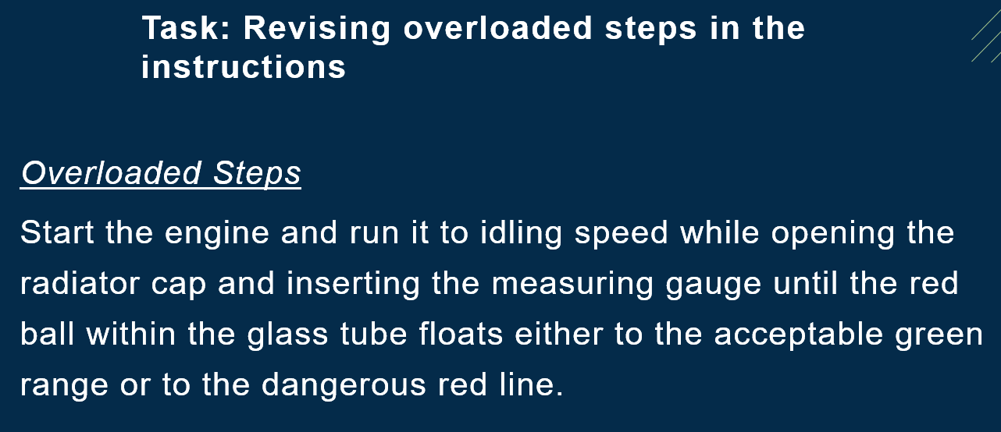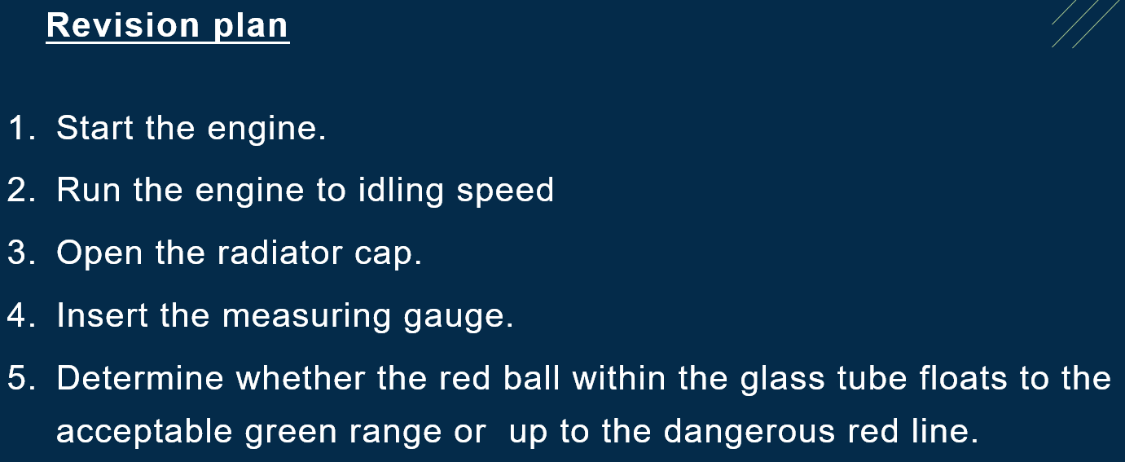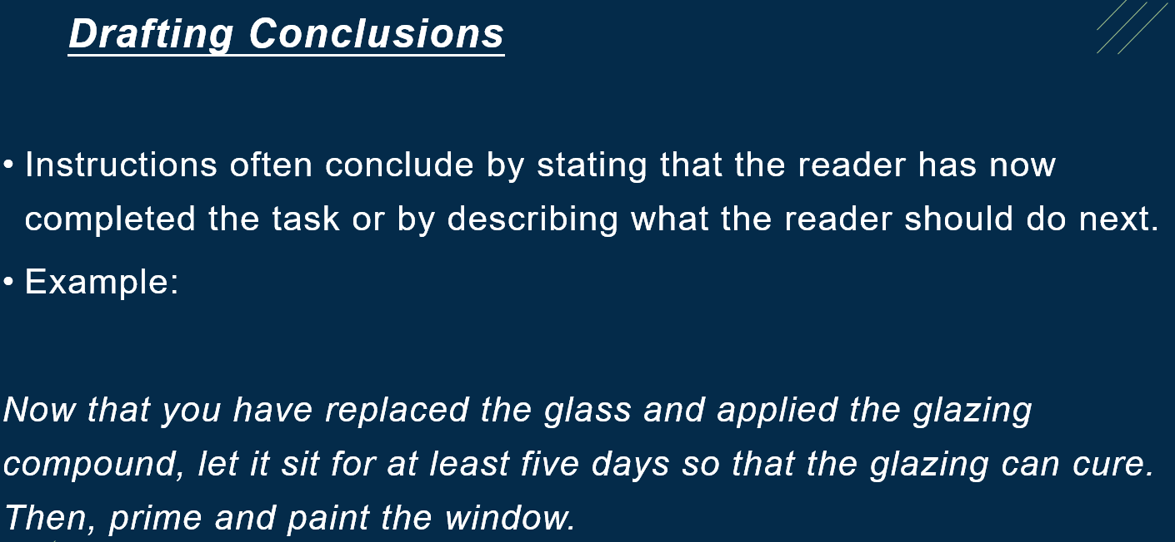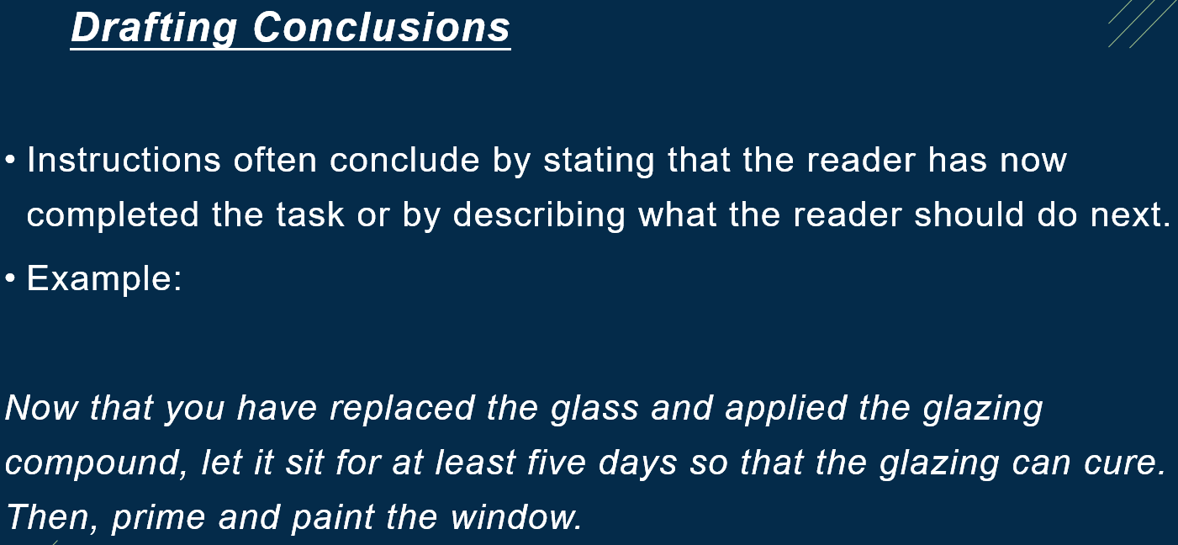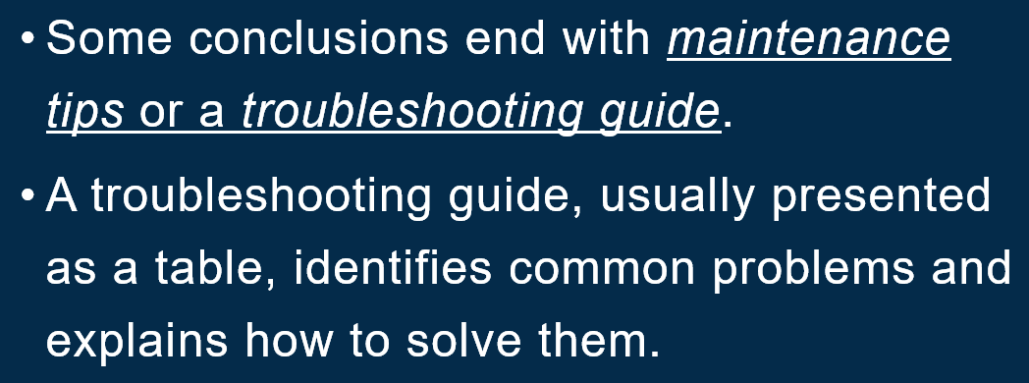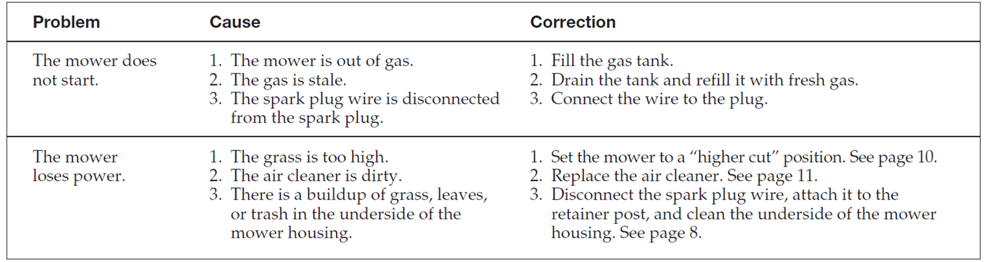

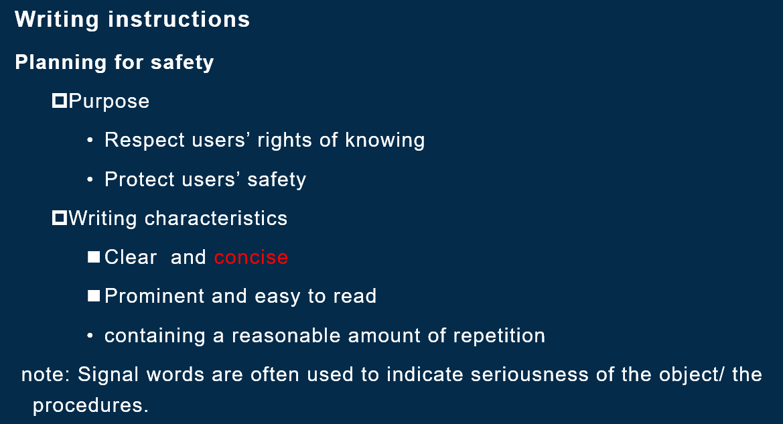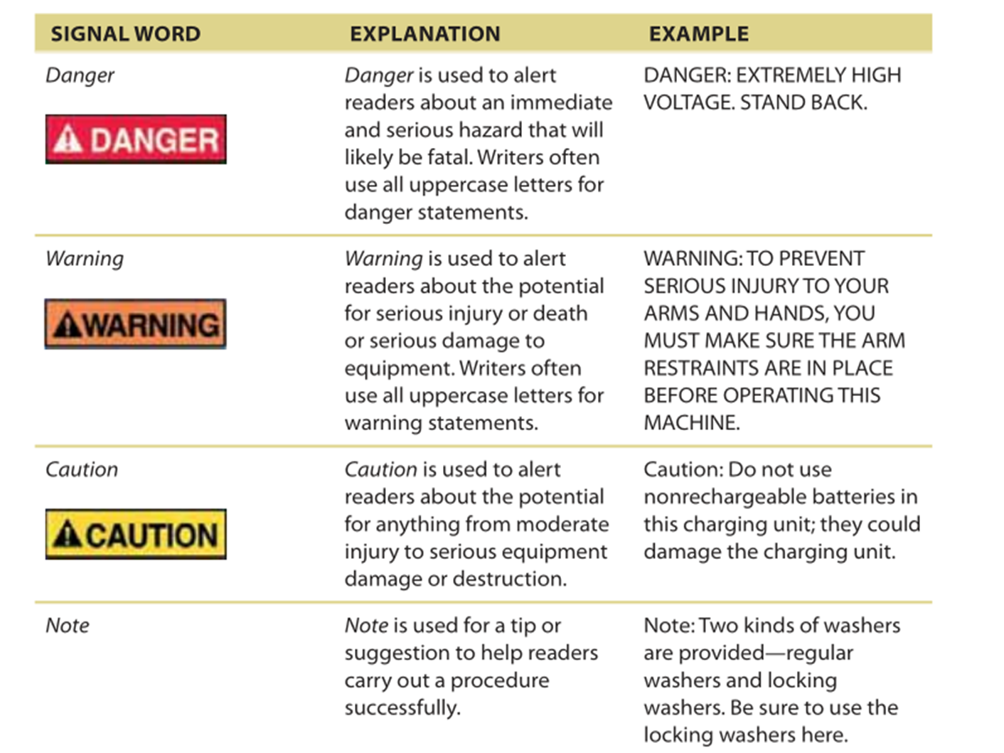

**Effective User Manuals**

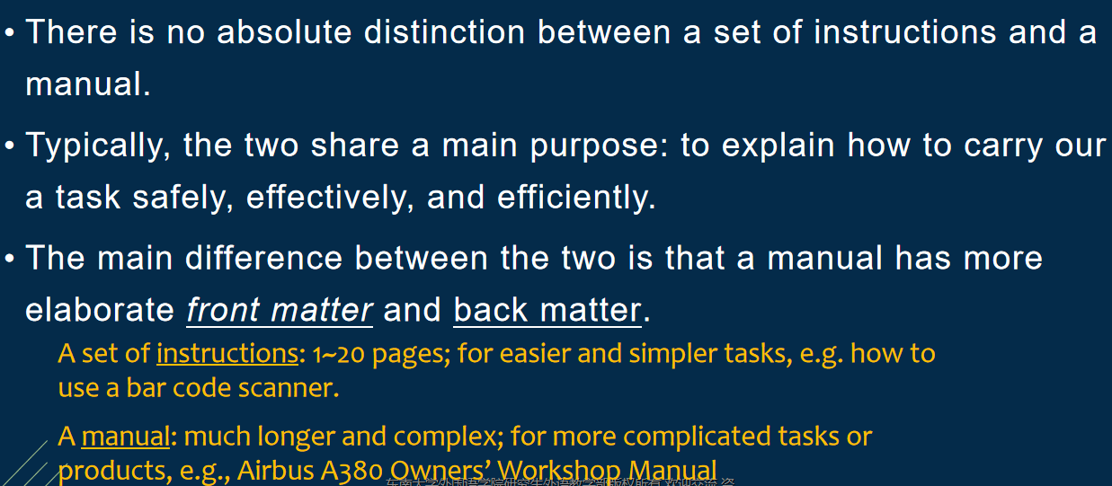

**Ethical Notes on Technical Communication:**

